Table of Contents

1 Ticket Lifecycle Workflow Manual

1.1 Purpose
This manual explains the complete ticket lifecycle from creation to closure in a clear step-by-step format, aligned with the documented sales call-verification gate, supervisor assignment flow, and technical execution-to-closure process.

1.2 How to Read This Manual
- Visual Flow: Quick path using arrow icons.
- Screens and Explanation: Image first, then direct explanation under the image.
- Detailed Steps: Line-by-line actions users must follow.

1.3 Arrow Legend
- -> next action
- => decision branch
- [Yes] positive decision output
- [No] negative decision output

1.4 Roles in This Workflow
- Sales: intake and verification for sales-created tickets
- Supervisor: assignment/reassignment, routing, escalation handling, and closure validation
- Technical Staff: diagnosis, execution, update, and proof submission

1.5 Stage 0: Intake Readiness
Prepare the required information before ticket creation: 1. Client identity and contact details 2. Product/equipment details (existing or new) 3. Service type and support preference 4. Initial problem statement
Visual Flow: Prepare client details -> Prepare product details -> Prepare service details -> Ready for ticket creation

1.6 Stage 1: Ticket Creation (Sales or Supervisor)
Visual Flow: Open Create Ticket -> Select Client Type -> Select Product Type -> Add Service + Problem -> Review -> Submit -> STF Generated (Open)

1.6.1 Screens and Explanation
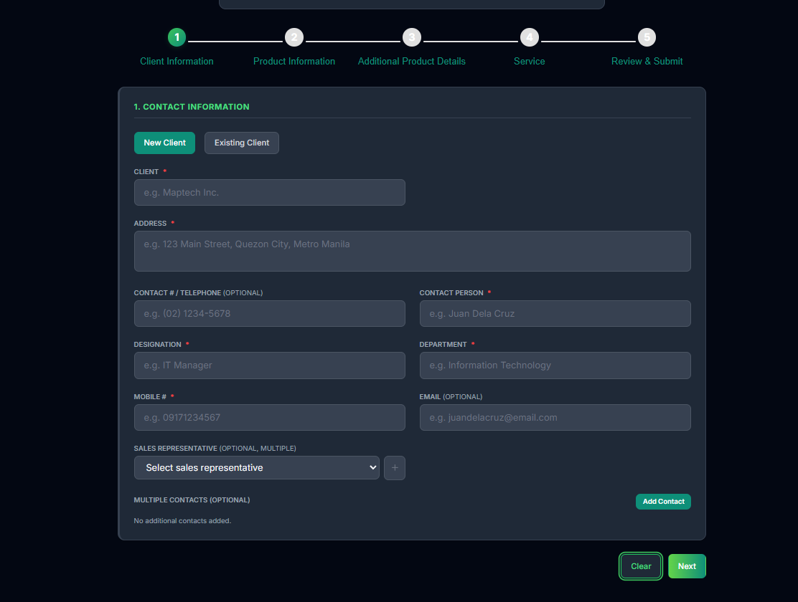 Explanation: Use this screen when encoding a first-time client profile.
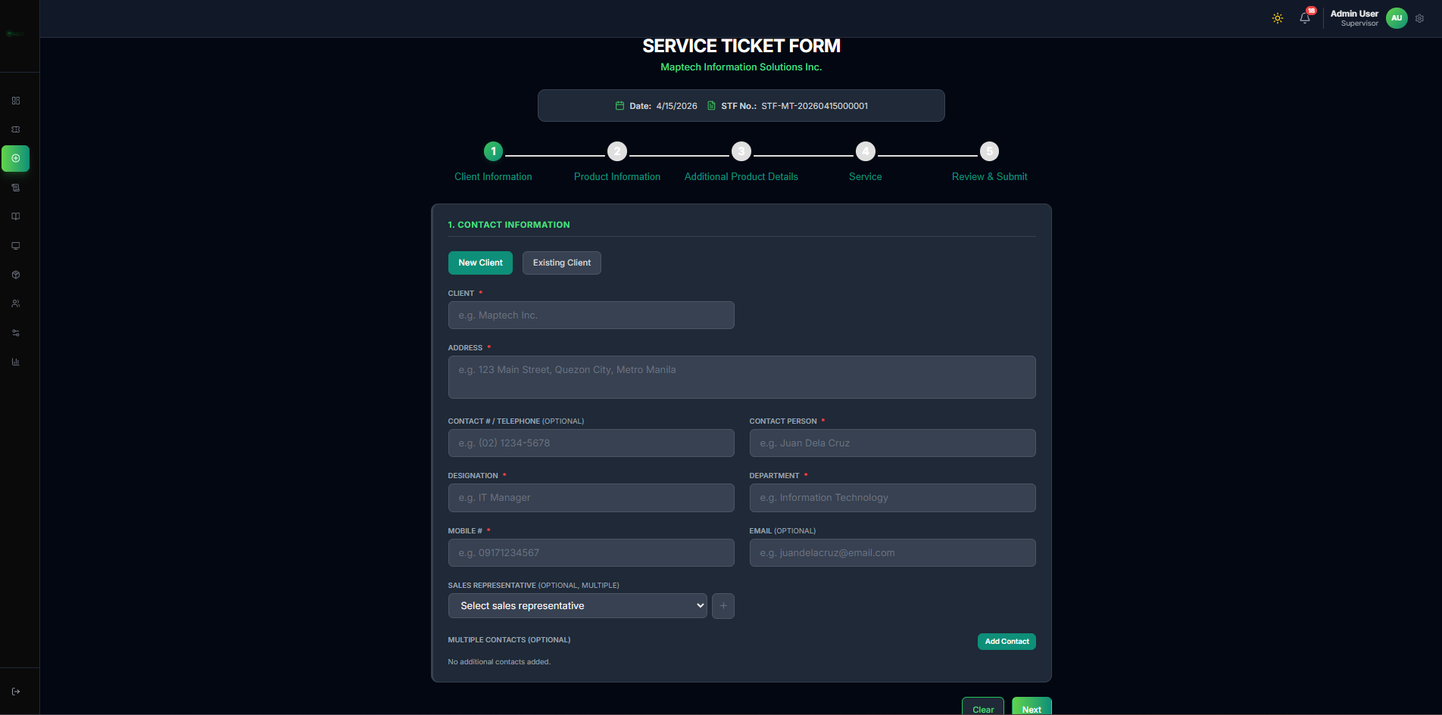 Explanation: Use this when the client already exists in the system and only ticket details are needed.
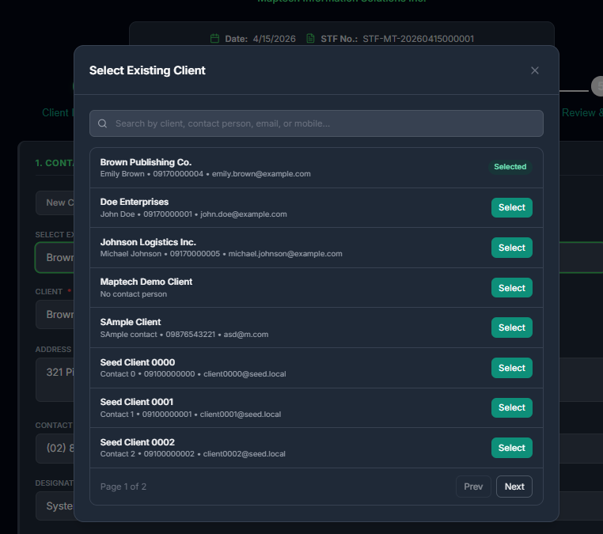 Explanation: Search and select the correct existing client record to avoid duplicate profiles.
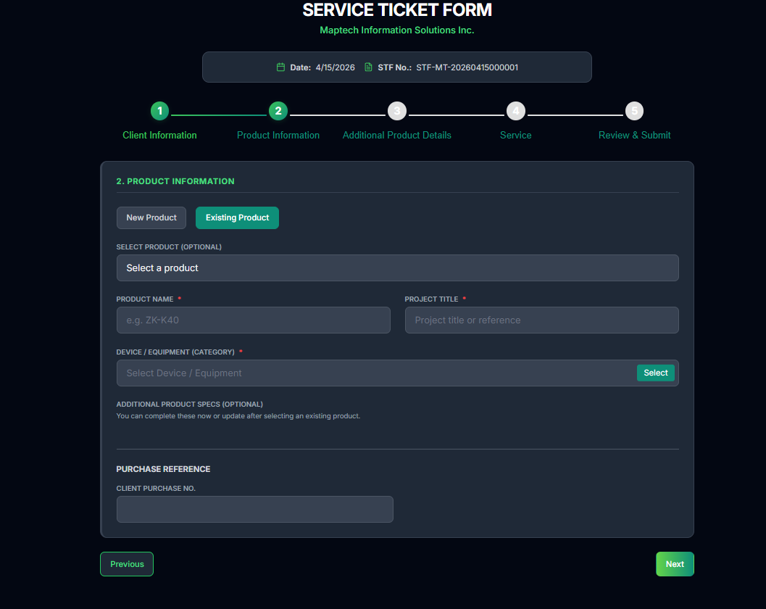 Explanation: Choose this if the product/equipment already exists in the catalog.
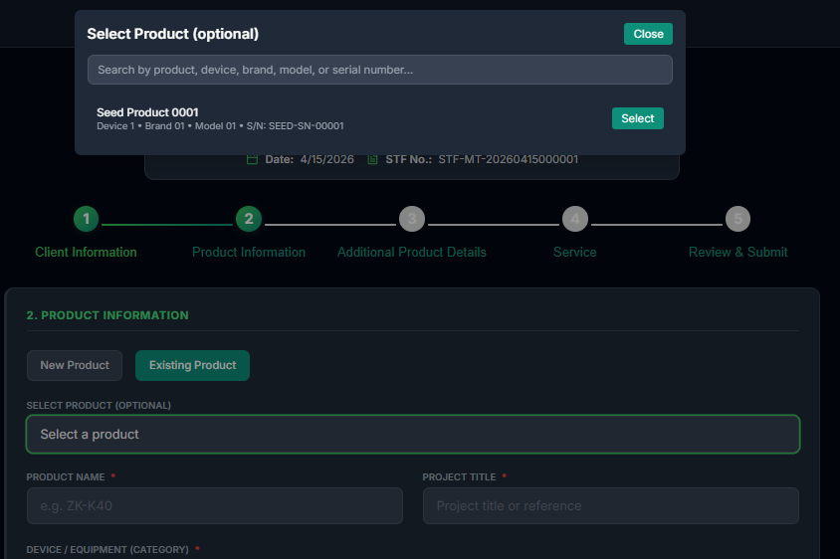 Explanation: Select the exact product model or registered item linked to the client concern.
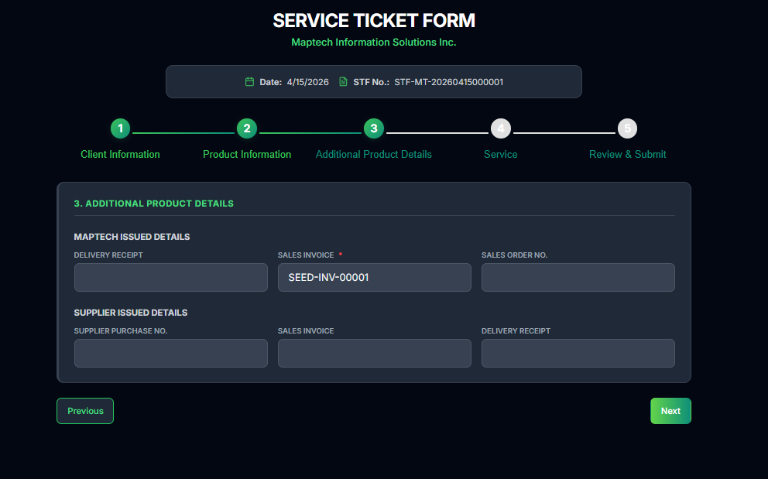 Explanation: Complete serial/reference and any extra technical fields to improve troubleshooting speed.
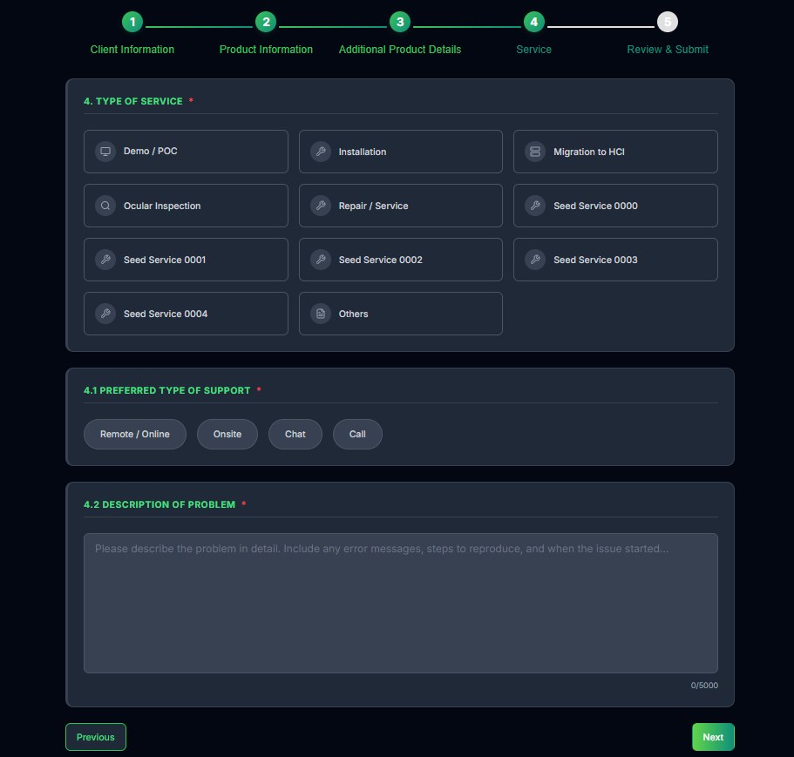 Explanation: Pick the service category and support preference that match the issue type.
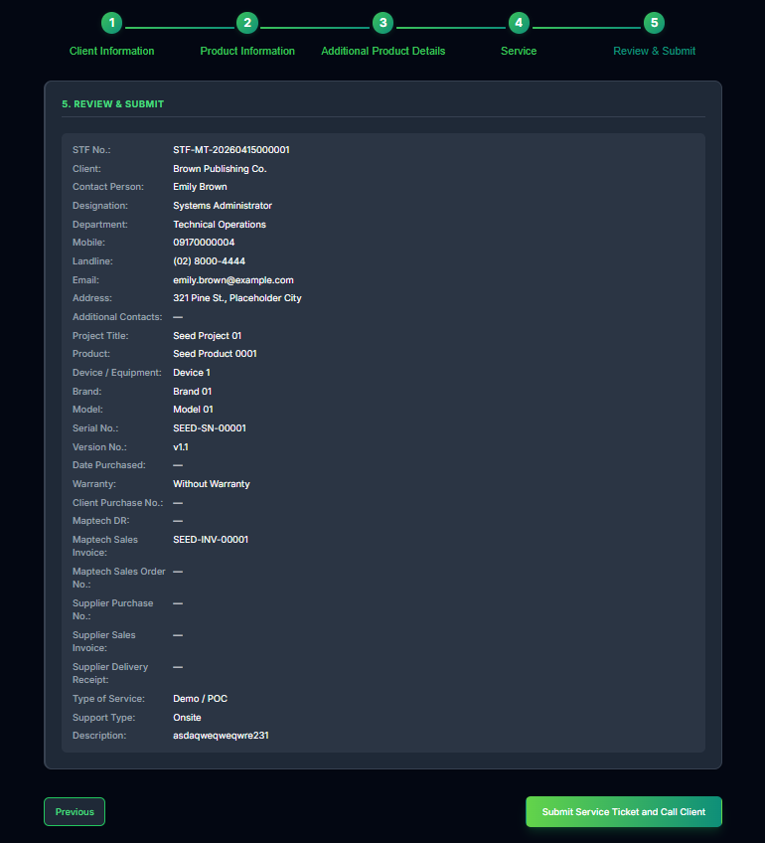 Explanation: Final review screen before creating the ticket and generating STF number.
 Explanation: Supervisor uses this when creating a ticket for an existing client and validating details quickly.
 Explanation: Supervisor uses this for new client onboarding during urgent or direct intake scenarios.
 Explanation: Supervisor client lookup modal for selecting verified client records.
 Explanation: Supervisor product lookup modal for selecting existing equipment/product details.
 Explanation: Supervisor final confirmation screen before submitting a newly encoded ticket.

1.6.2 Detailed Steps
- Open Create Ticket and select New Client or Existing Client.
- If Existing Client, search and select the client from the modal.
- Enter or validate contact and organization details.
- Select New Product or Existing Product.
- If Existing Product, select the product from the modal.
- Fill additional product/reference fields.
- Select service type and support preference.
- Enter complete problem description.
- Review all details and submit.
- System generates STF number and ticket status becomes Open.

1.7 Stage 2: Sales Call Verification and Priority Setup
Visual Flow: Ticket Created (Sales) -> Perform Client Call Verification -> Review Ticket -> Set Priority -> Confirm Ticket -> Route to Supervisor Assignment

1.7.1 Screens and Explanation
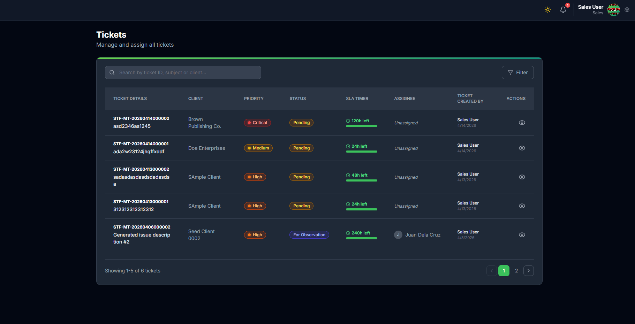 Explanation: Sales verification and review reference before routing ticket to supervisor assignment.
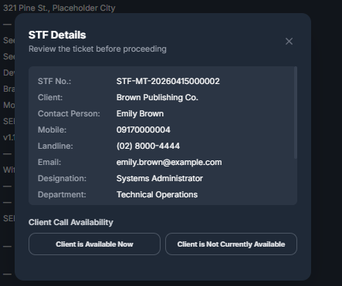 Explanation: Supervisor-side verification view showing STF details, client call availability decision, contact selection, priority selection, and call log preview before assignment.
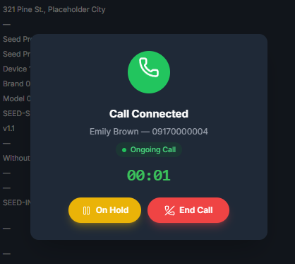 Explanation: Active call state used while validating client details; supervisor can place the call on hold or end the call, then continue workflow once call is completed.
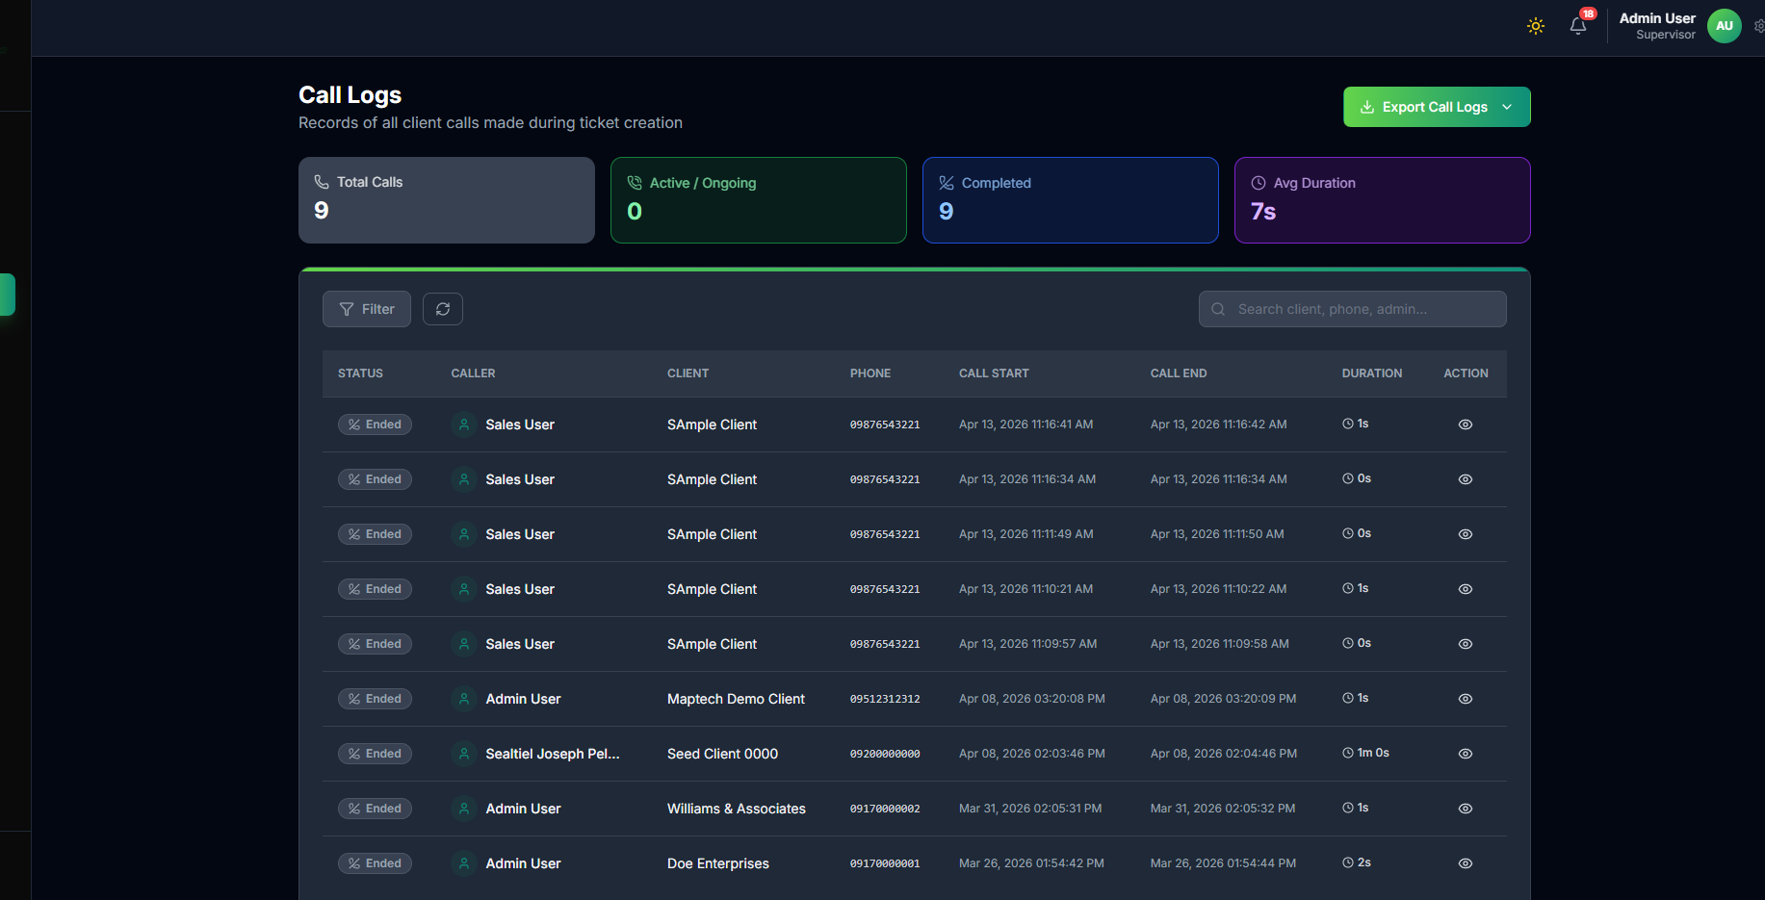 Explanation: Call records provide verification traceability for completed and unsuccessful attempts.

1.7.2 Detailed Steps
- Sales opens the newly created ticket from sales ticket views.
- Sales performs client call verification and confirms issue context.
- Sales records call workflow details for traceability.
- Sales reviews ticket completeness and data accuracy.
- Sales sets priority (Critical, High, Medium, Low, Unknown).
- During supervisor-side review, call may enter active connected state (Ongoing Call) while confirmation is in progress.
- Supervisor completes call action, records outcome, and validates priority where applicable.
- Sales confirms ticket for operational handling.
- System marks ticket ready for supervisor assignment routing.
- Supervisor receives confirmed ticket in assignment queue.
- Ticket proceeds to supervisor assignment stage.

1.8 Stage 3: Supervisor Assignment and Reassignment
Visual Flow: Open Ticket Queue -> Open Assign Technical Modal -> Review Technician Workload -> Assign Ticket -> Monitor Progress => [Issue in fit/progress] Reassign -> Continue Work
State Routing Flow: Open -> In Progress -> Pending Closure -> Closed

1.8.1 Screens and Explanation
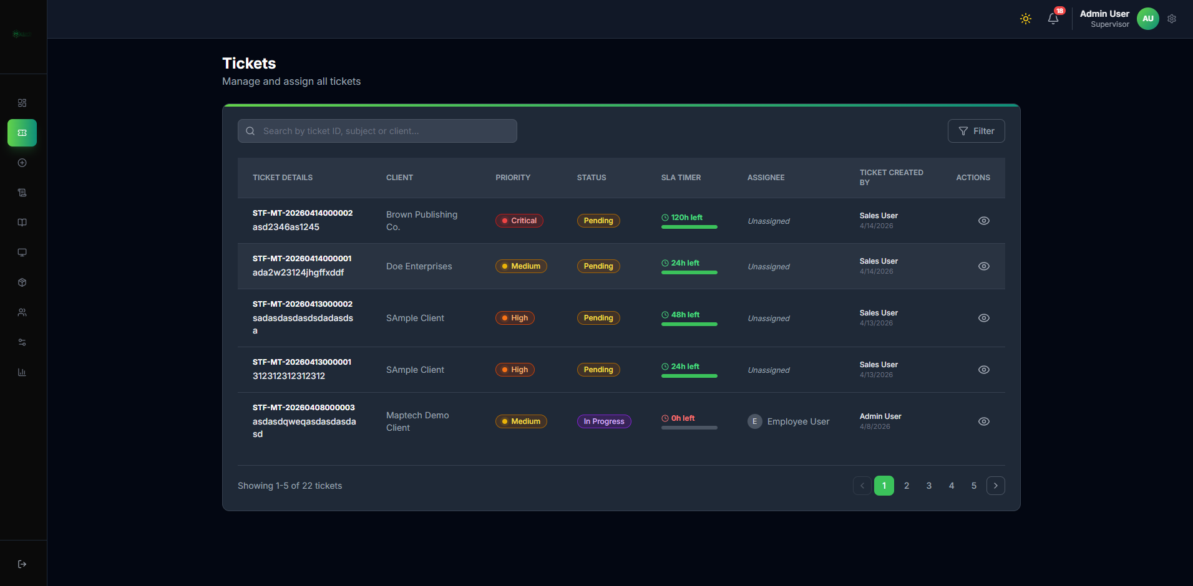 Explanation: Main list for opening incoming or self-created verified tickets and starting assignment action.
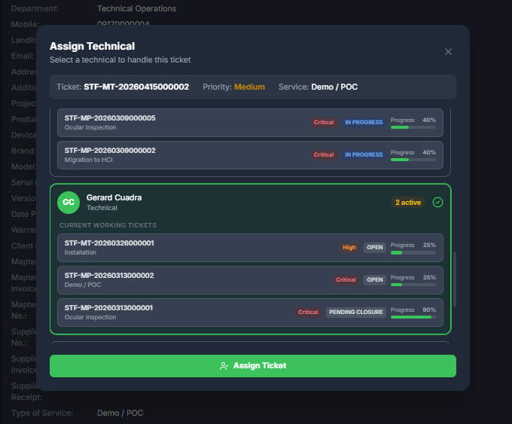 Explanation: Assignment modal where supervisor compares technician current working tickets, progress, and active load before assigning.
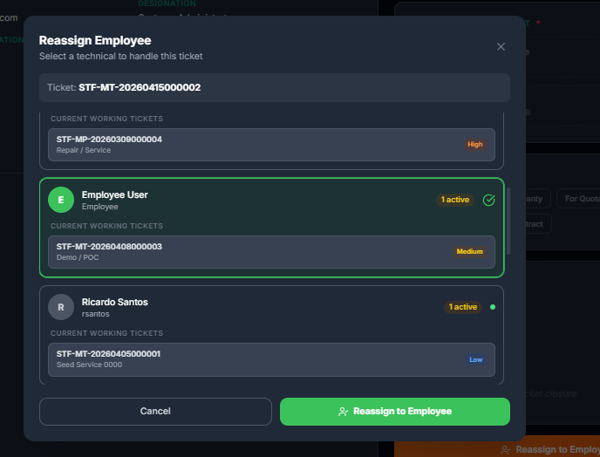 Explanation: Reassignment view used when workload, skill mismatch, or escalation requires changing the assigned technician.
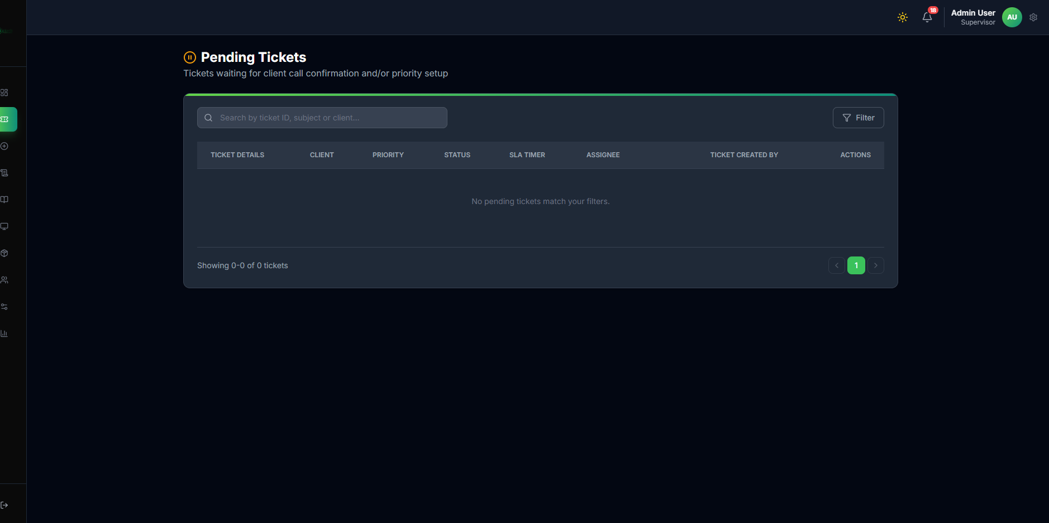 Explanation: Queue used to process tickets that still need assignment or immediate routing action.
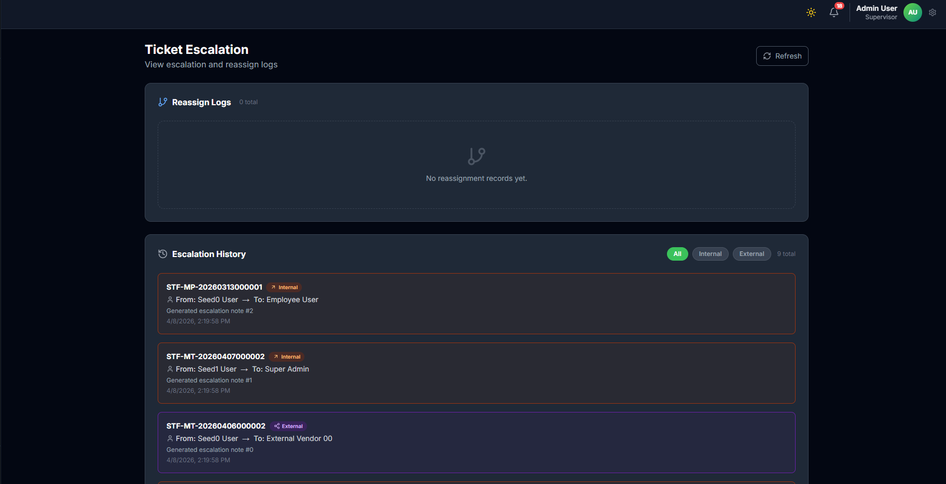 Explanation: Used when reassignment is required due to escalation or capability mismatch.
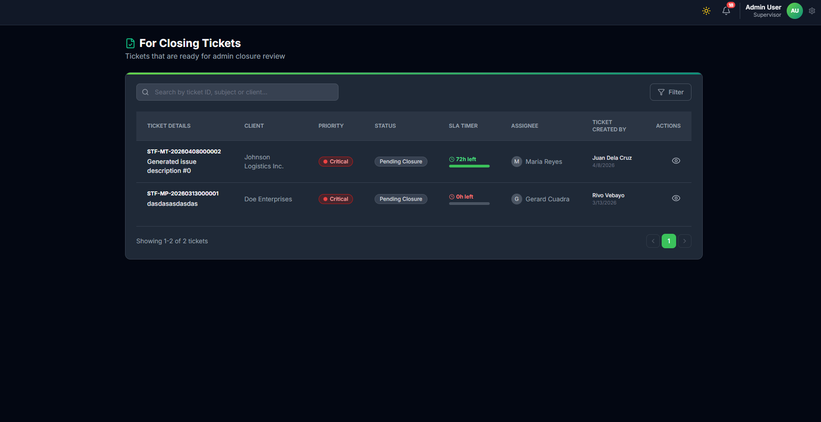 Explanation: Queue for tickets already requesting closure and waiting for supervisor validation.
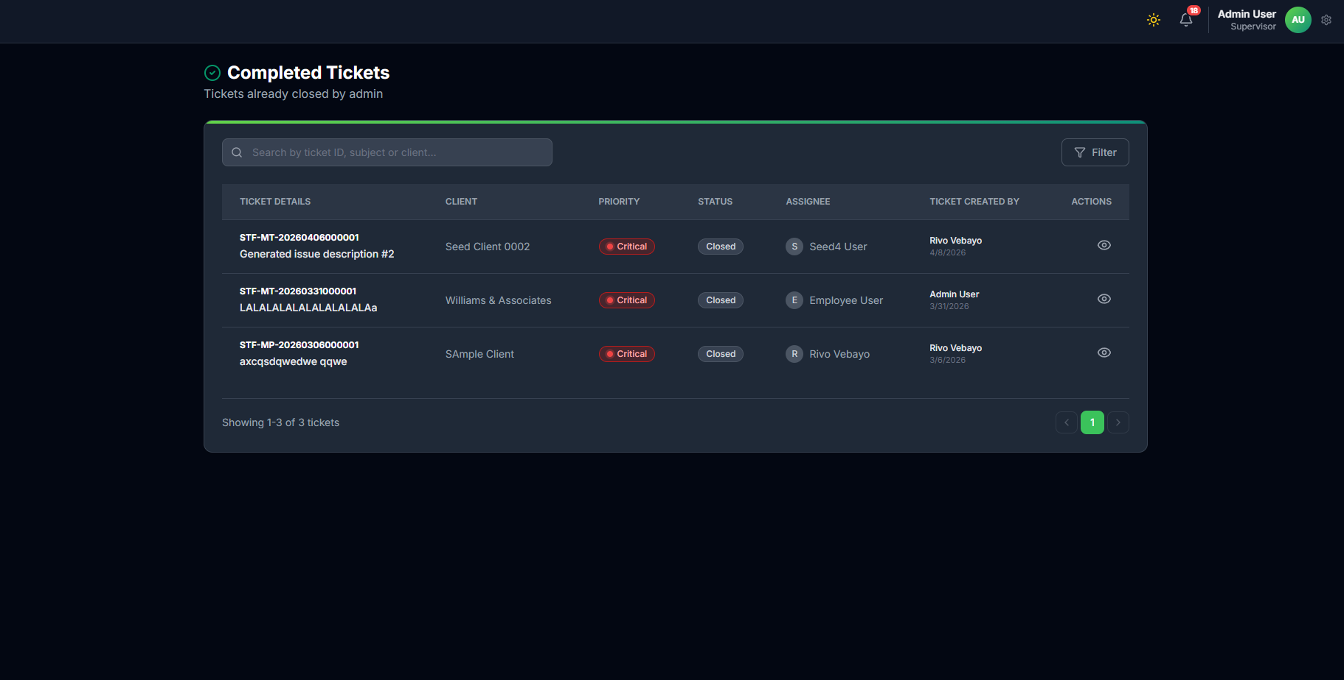 Explanation: Final record where supervisor confirms successful closure and quality of completion.

1.8.2 Detailed Steps
- Open verified ticket from All/Pending queues.
- Validate ticket details and priority before dispatch.
- Open Assign Technical modal.
- Review technician load using active ticket count, current ticket list, and progress indicators.
- Assign the best-fit technician based on availability and capability.
- Ticket becomes visible in technical assigned queue.
- Monitor progress, SLA, and blockers.
- Reassign when initial assignment is not suitable, ticket is stalled, or escalation requires different expertise.
- Route ticket actions based on lifecycle state (Open, In Progress, Escalated, Escalated External, For Observation, Pending Closure, Closed, Unresolved).

1.9 Stage 4: Technical Execution
Visual Flow: Assigned -> Open Ticket Details -> Start Work -> In Progress -> Fill Required Work Fields -> Choose Next Action
Technical Decision Flow: Choose Next Action => [Resolved] Request Closure -> Confirm Request -> Pending Closure
Observation Decision Flow: Choose Next Action => [Needs Monitoring] Submit for Observation -> Confirm Submit -> For Observation
Escalation Decision Flow: Choose Next Action => [Cannot Resolve at Current Level] Escalate => [Internal] Add Notes/Reason -> Submit Escalation -> Escalated
External Escalation Decision Flow: Choose Next Action => [Cannot Resolve at Current Level] Escalate => [External] Enter Distributor/Vendor Name + Notes/Reason -> Submit Escalation -> Escalated External

1.9.1 Screens and Explanation
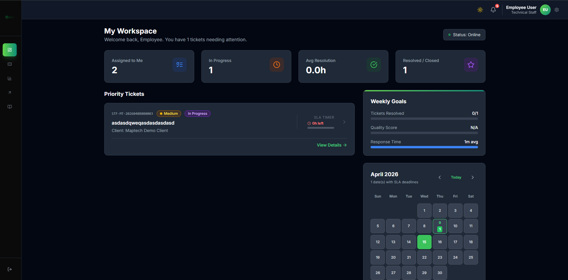 Explanation: Technician dashboard for work visibility, priorities, and assignment awareness.
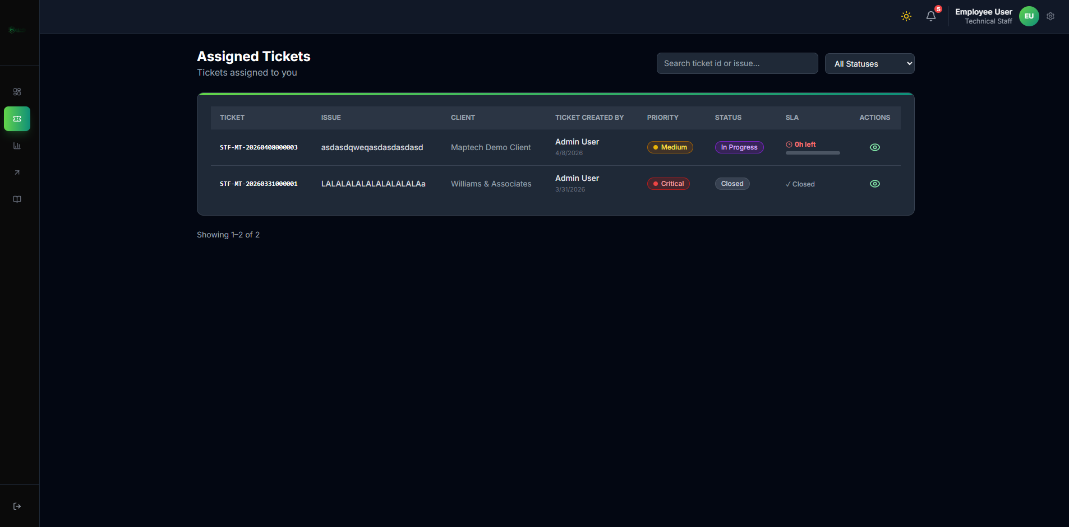 Explanation: Assigned ticket worklist where technician opens and updates ticket progress.
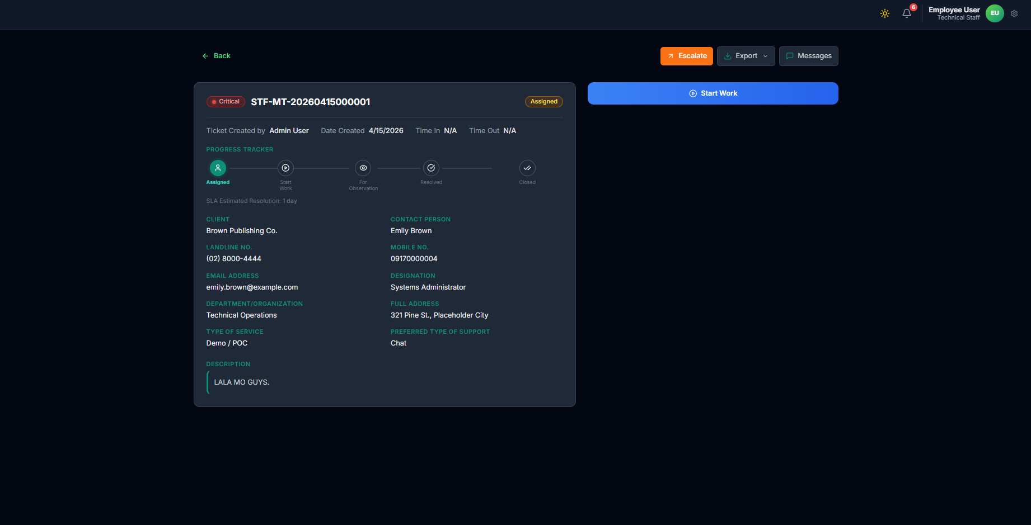 Explanation: Assigned-state ticket details page where technician reviews context and starts execution.
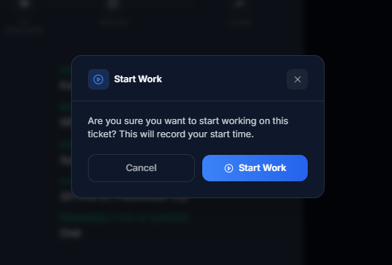 Explanation: Start Work confirmation modal that records the technician time-in and moves activity into active execution.
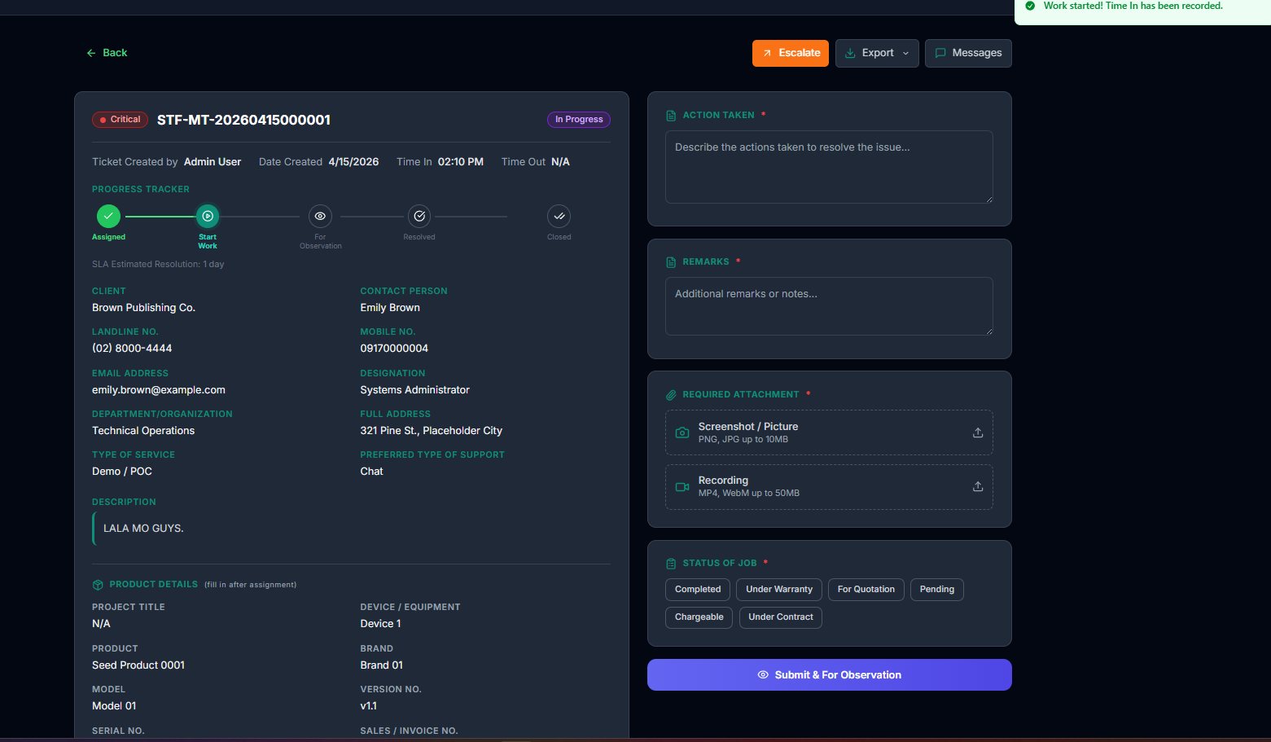 Explanation: In-progress work form where technician encodes action taken, remarks, attachments, and status of job.
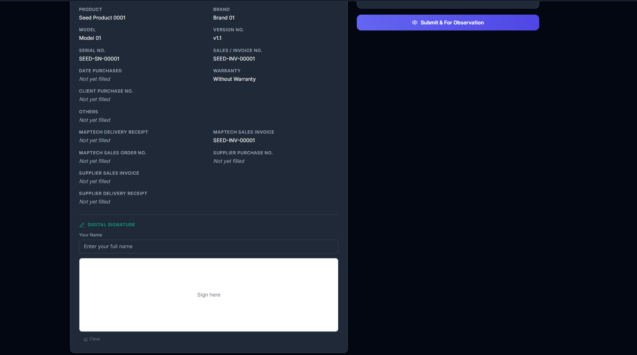 Explanation: Extended in-progress area including product details and digital signature capture required for formal submission.
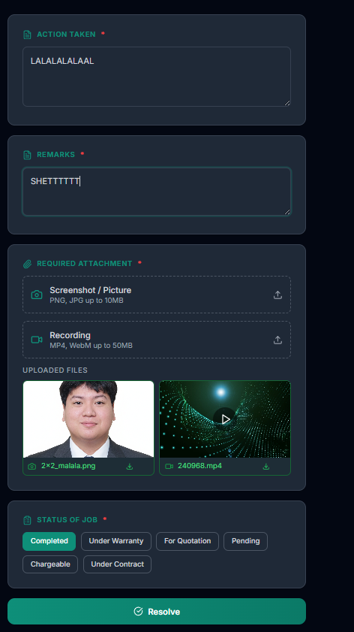 Explanation: Example of completed required inputs before triggering request-closure action.
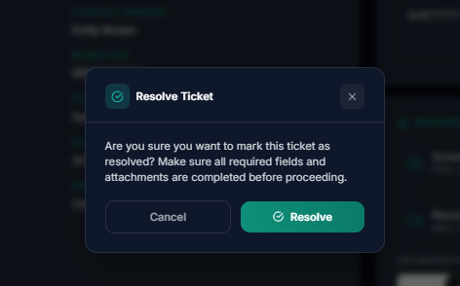 Explanation: Request-closure confirmation modal shown before sending the ticket to supervisor closure review.
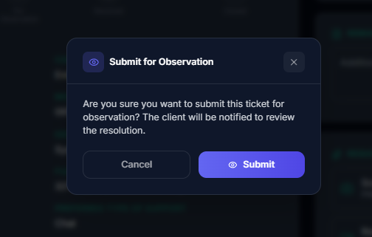 Explanation: Observation confirmation modal used when issue behavior requires monitoring before final closure.
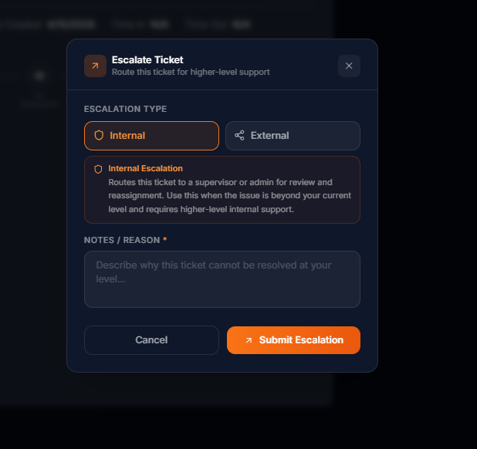 Explanation: Internal escalation modal where technician routes ticket to supervisor/admin with required notes/reason.
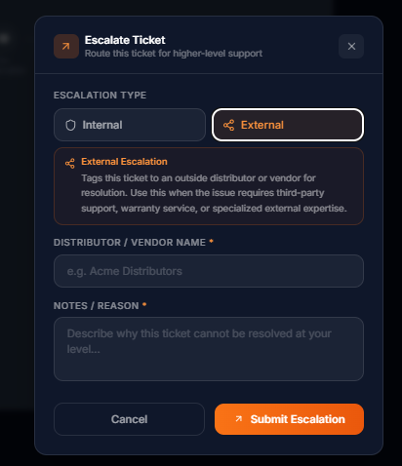 Explanation: External escalation modal where technician routes ticket to outside vendor/distributor and must provide distributor/vendor name plus notes/reason.

1.9.2 Detailed Steps
- Technician receives assignment.
- Technician opens assigned ticket details and reviews full ticket context.
- Technician clicks Start Work and confirms in Start Work modal.
- System records time-in and ticket moves to active In Progress state.
- Technician performs diagnosis and corrective action.
- Technician completes Action Taken and Remarks fields.
- Technician uploads required attachments (screenshot/picture and recording as applicable).
- Technician selects Status of Job based on actual outcome (Completed, Under Warranty, For Quotation, Pending, Chargeable, Under Contract).
- Technician completes digital signature section.
- Technician chooses one of three paths: Request Closure, Submit for Observation, or Escalate.
- If resolved, technician submits request closure and confirms in modal.
- Ticket proceeds to supervisor review path (Pending Closure).

1.10 Stage 5: Branching During Work (Escalation, Pass, and Observation Control)
Escalation Branch Flow: In Progress => [Cannot Resolve at Current Level] Open Escalate Modal => [Internal] Add Notes/Reason -> Submit Escalation -> Supervisor Reassess/Reassign
External Escalation Branch: In Progress => [Needs Third-party Support] Open Escalate Modal => [External] Enter Distributor/Vendor Name + Notes/Reason -> Submit Escalation -> Supervisor Tracks External Resolution
Pass Ticket Branch: In Progress => [Needs Technician Handoff] Pass Ticket -> Select Target Technician + Notes -> New Assignment Session -> Continue Work
Observation Branch: In Progress => [Needs Monitoring] Submit for Observation -> Confirm Submit -> For Observation -> Monitor Result -> Back to In Progress or Move to Pending Closure

1.10.1 Screens and Explanation
 Explanation: Internal escalation action window with mandatory notes/reason before submit.
 Explanation: External escalation action window requiring distributor/vendor name and notes/reason before submit.
 Explanation: Confirmation modal for moving ticket into observation state.
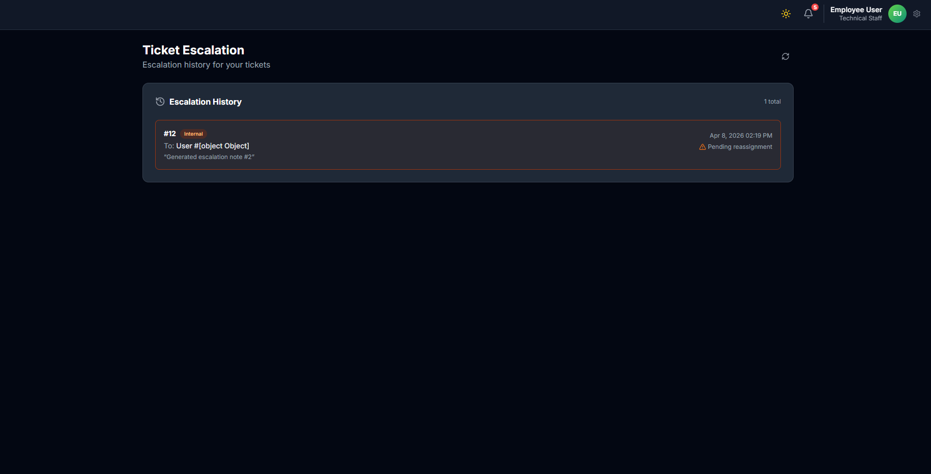 Explanation: Technician escalation evidence trail showing why escalation was raised.
 Explanation: Supervisor reassessment and reassignment reference for escalated tickets.

1.10.2 Detailed Steps
- If unresolved at current level, technician opens Escalate or Pass action.
- For internal escalation, technician selects Internal and enters notes/reason.
- For external escalation, technician selects External, enters distributor/vendor name, and adds notes/reason.
- For technician handoff, technician uses Pass flow, selects target technician, and adds pass notes.
- System submits escalation/pass and updates ticket path (Escalated, Escalated External, or new assignment session).
- Supervisor validates escalation context and routes reassignment or external tracking.
- Ticket returns to active execution path when reassigned or when external updates allow continued work.
- If monitoring is required instead, technician submits ticket for observation.
- Observation outcome routes ticket back to In Progress or forward to Pending Closure.

1.11 Stage 6: Closure Request and Supervisor Review
Visual Flow: Pending Closure -> Review Notes and Proof -> Submit Feedback -> Close Ticket -> Verify in Completed

1.11.1 Screens and Explanation
 Explanation: Supervisor review queue for closure requests awaiting final validation.
 Explanation: Final closure confirmation list and post-resolution history check.

1.11.2 Detailed Steps
- Ticket moves to Pending Closure after technician request.
- Supervisor reviews proof and work notes for completeness and accuracy.
- Supervisor confirms the outcome matches original issue scope.
- Supervisor submits technical feedback/rating.
- Supervisor closes ticket and confirms status Closed.
- Supervisor verifies ticket appears in completed queue/history.

1.12 Stage 7: Knowledge Capture (Optional but Recommended)
Visual Flow: Closed Ticket -> Open Attachment Repository -> Publish Reusable Proof -> Knowledge Available to Team

1.12.1 Screens and Explanation
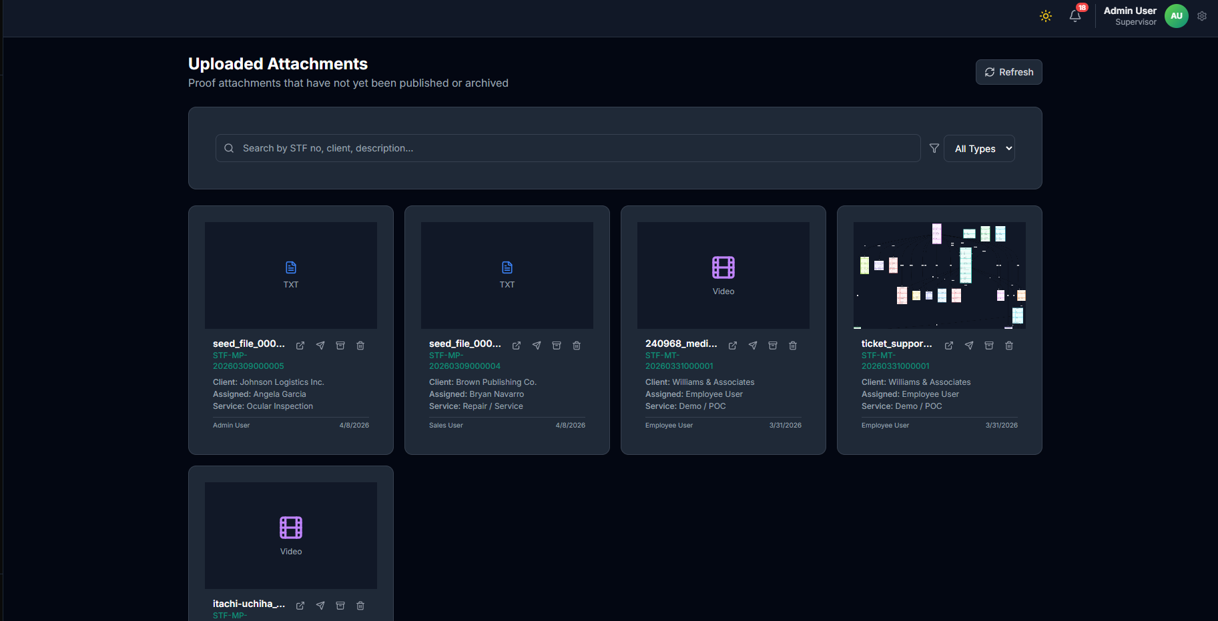 Explanation: Upload area where supervisor selects resolved-ticket evidence for publication.
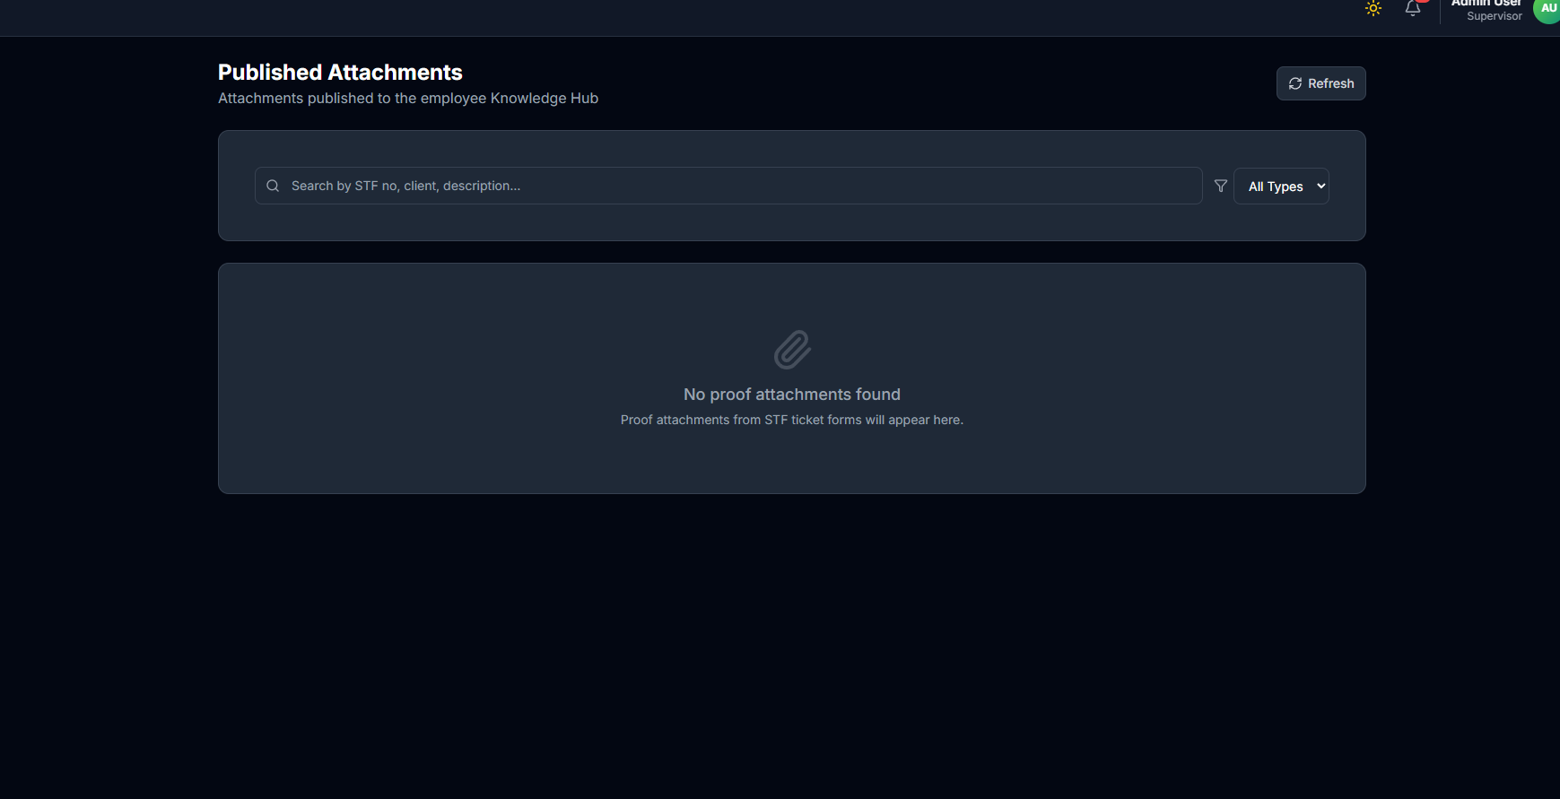 Explanation: Publication page for adding title, summary, and tags to reusable solutions.

1.12.2 Detailed Steps
- Open attachment repository from resolved tickets.
- Select reusable and valid proof file.
- Publish as knowledge content with clear tags and description.
- Confirm published item is searchable by technical staff.

1.13 Supervisor Resolution Gate (Mandatory)
- Ticket is in Pending Closure before final close.
- Technical action notes and remarks are complete.
- Proof attachments are valid and relevant.
- Feedback/rating is submitted.
- Closure is verified in completed history.

1.14 Ticket Lifecycle Control Matrix
- Creation control: Sales/Supervisor
- Verification and call control: Sales (sales-created ticket workflow)
- Assignment and reassignment control: Supervisor
- Execution control: Technical Staff
- Escalation control: Technical Staff + Supervisor
- Closure control: Supervisor
- Governance visibility: Superadmin

1.15 Mandatory Validation Checklist per Ticket
- Client and service details are complete.
- Sales call verification and priority confirmation are completed for sales-created tickets before supervisor assignment.
- Priority is set before assignment routing.
- Assignment or reassignment is performed by supervisor when required.
- Work notes are updated before closure request.
- Evidence files are attached before closure request.
- Supervisor feedback/rating is submitted before final close.

1.16 Quick State Path
Open -> In Progress -> Pending Closure -> Closed
Alternate Paths: - In Progress -> Escalated -> In Progress - In Progress -> Escalated External -> In Progress/Pending Closure - In Progress -> For Observation -> In Progress/Pending Closure - In Progress -> Unresolved -> In Progress

